CS551 Lab3 Report RAKESH VIDEM

**Application Name:** Know Your Kansas City

**Description:**  Know Your Kansas City is a Mobile Web client Application developed to know about Kansas City. The main features of the app are

* To find Geo-Location of Kansas City.
* To find the Current Weather of Kansas City.
* To Tweet the Current Weather on Twitter. - Newly added
* To find directions in Kansas City
* Kansas City tour Video.
* Kansas City places to visit.
* Provide Feedback for the App - Newly Added

This app is built using the Javascript, HTML5, CSS3 and jQuery. Used Opera Mobile Emulator to generate the screens to view this mobile web app.

Jsfiddle Link for the app: <http://jsfiddle.net/rvbnd/ZHPnz/38/>

# Extend the Mobile Web Client Application you implemented in Lab 2 with HTML5 Local Database

**Screen Shot of jsfiddle:**  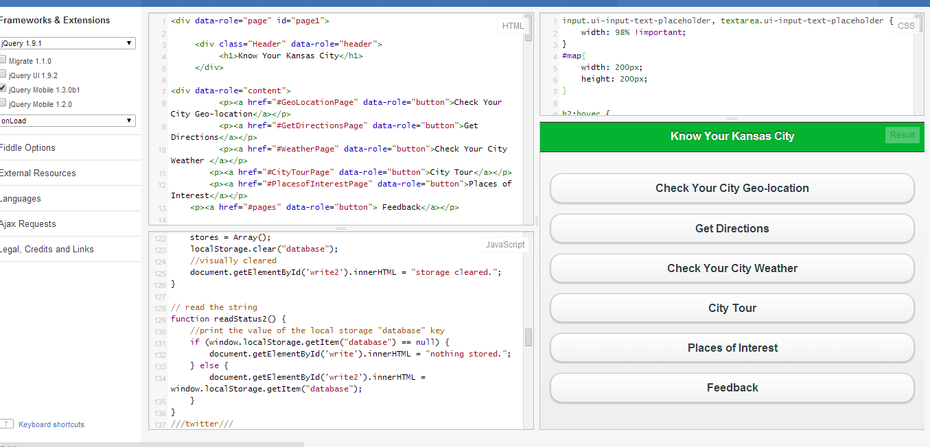

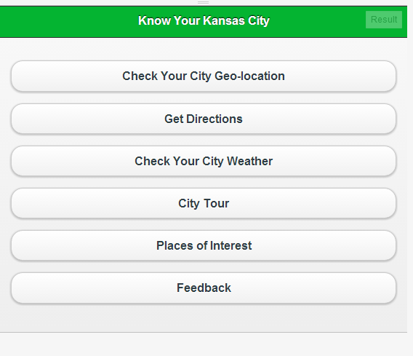

**Store Comment**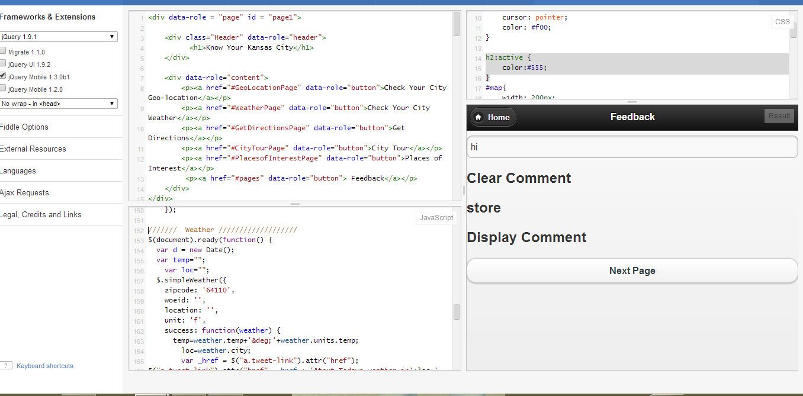

**Display Comment**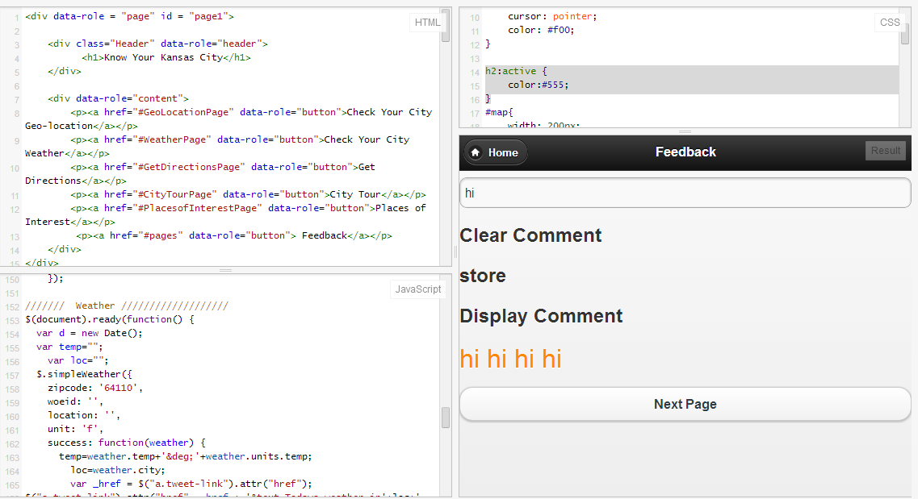

**Clear Comment**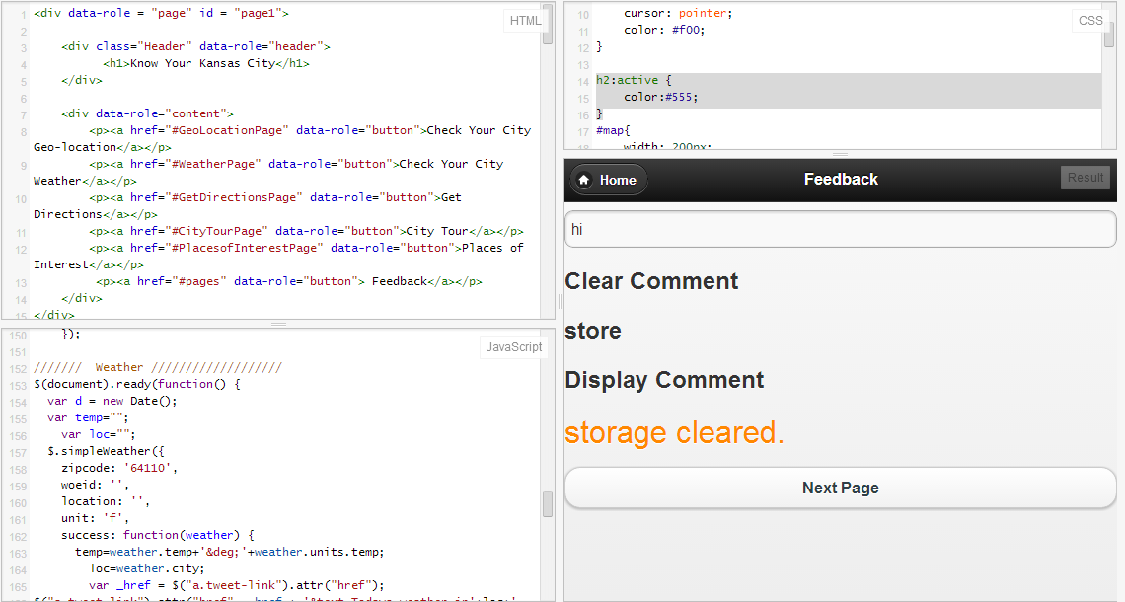

**Clearing the storage in next page**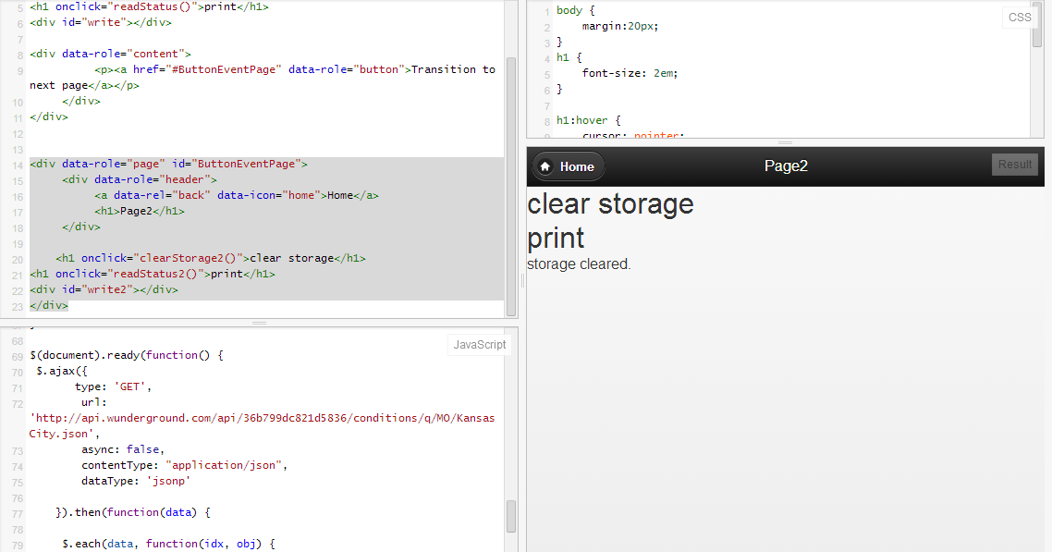

# Mashup application including various services

**Weather Report for Kansas City**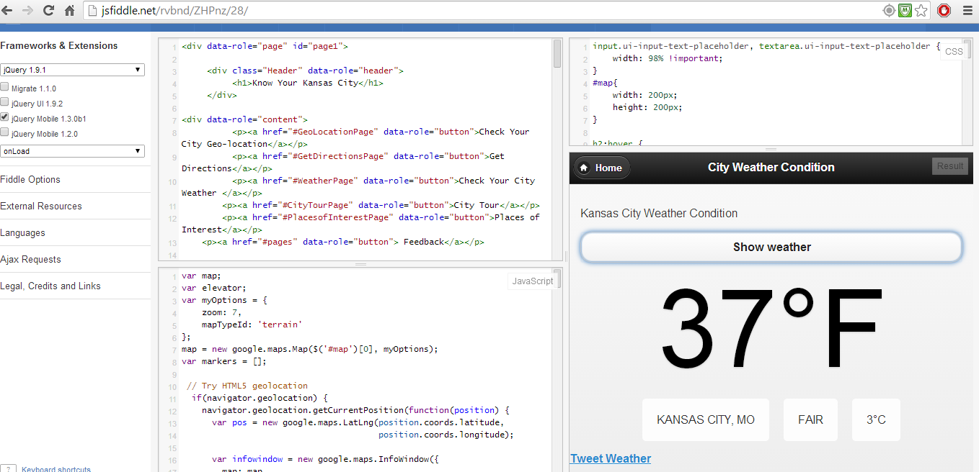

**Tweet Weather**

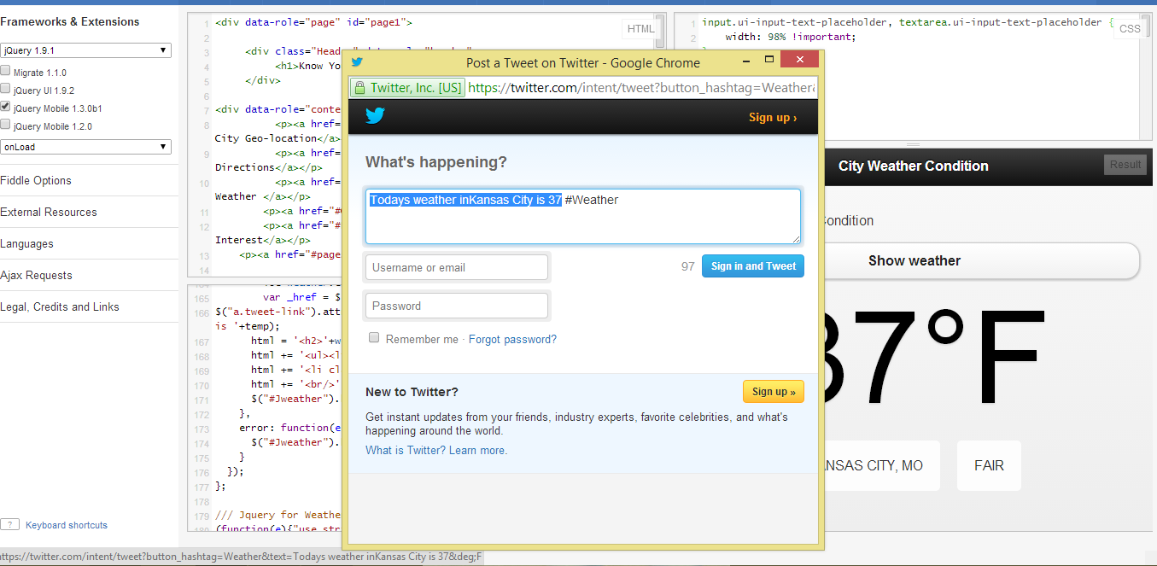

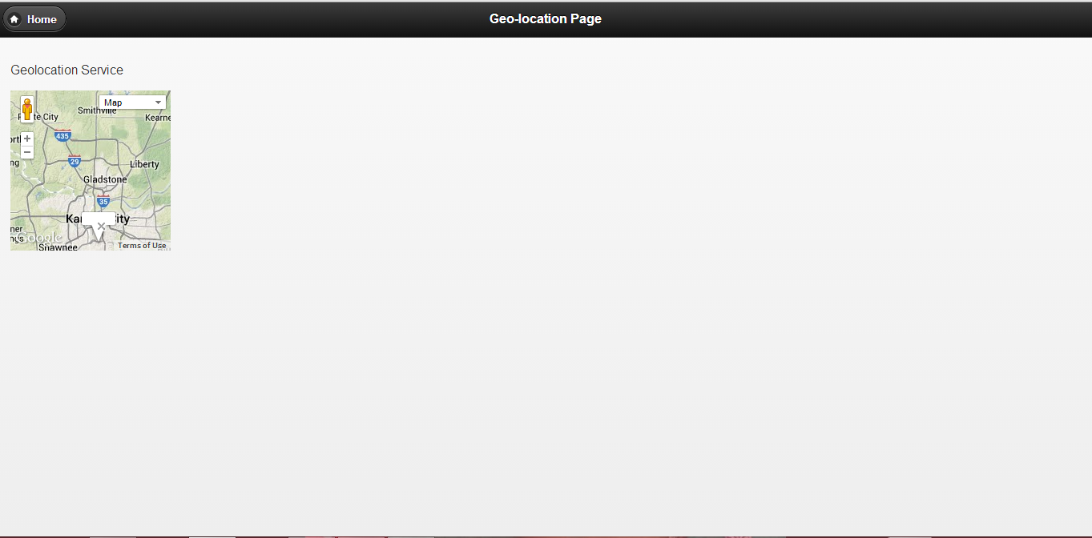

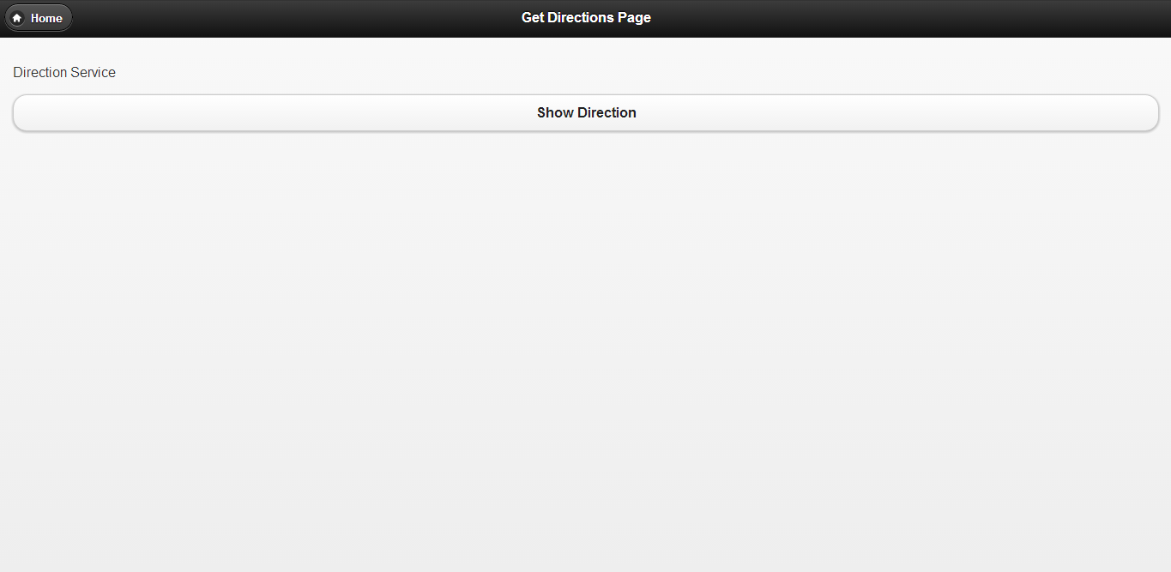

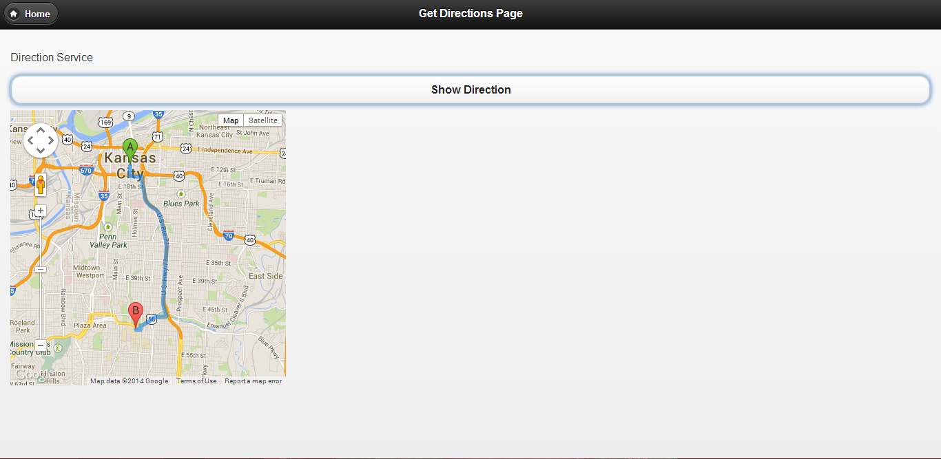

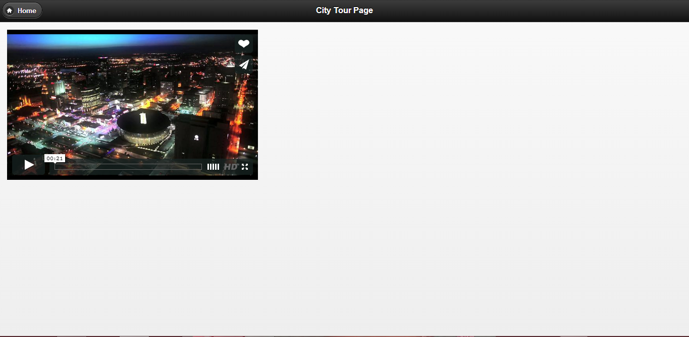

# Implementing own REST Web Services and using them from our own client application

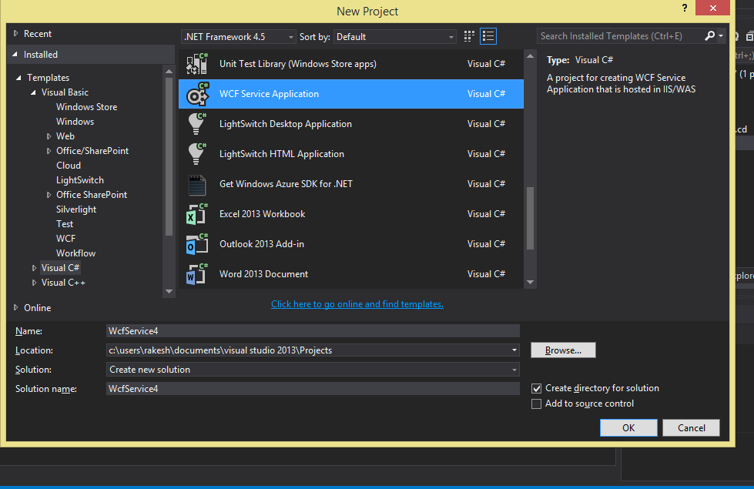

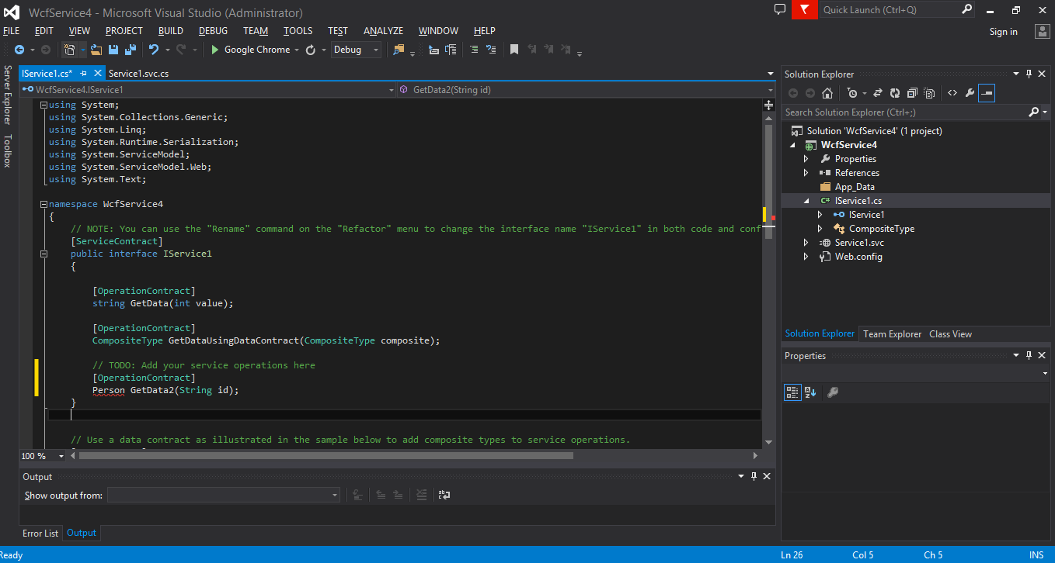

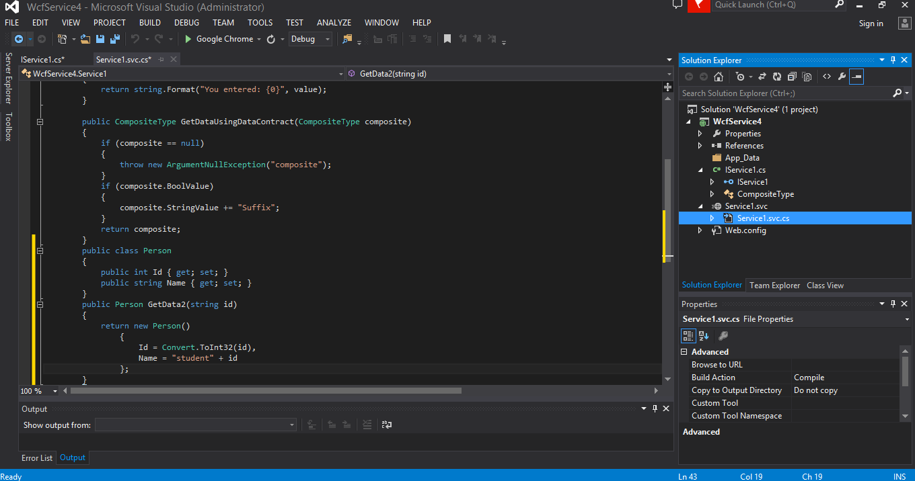

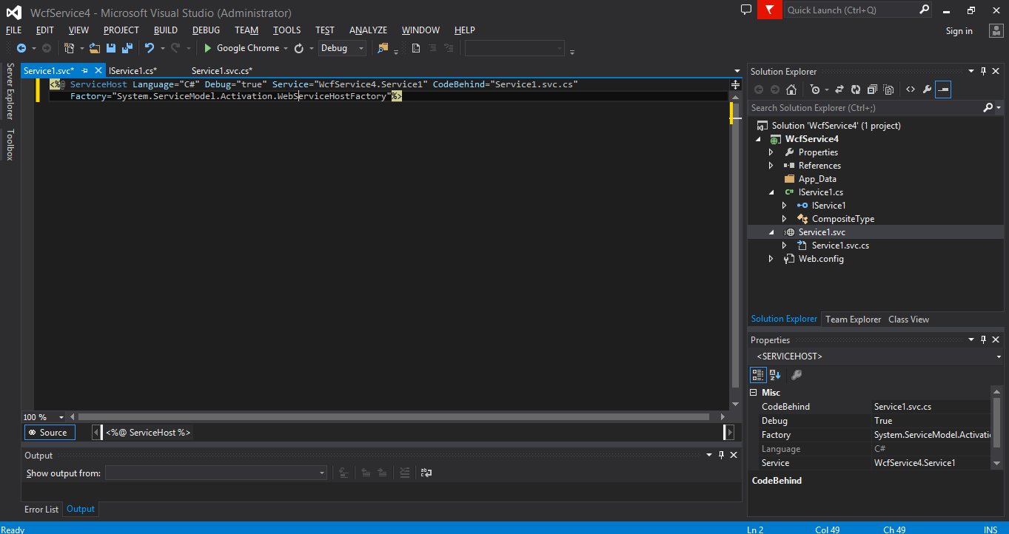

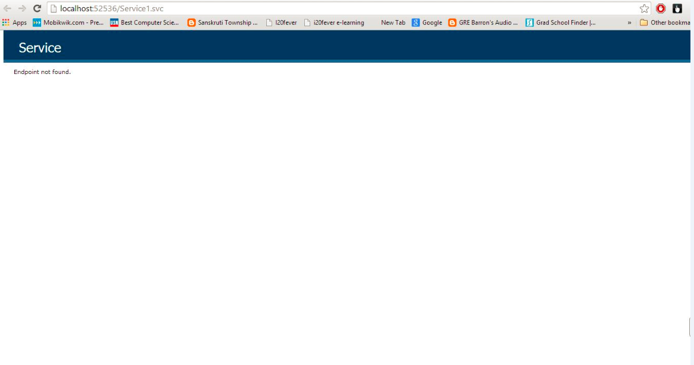

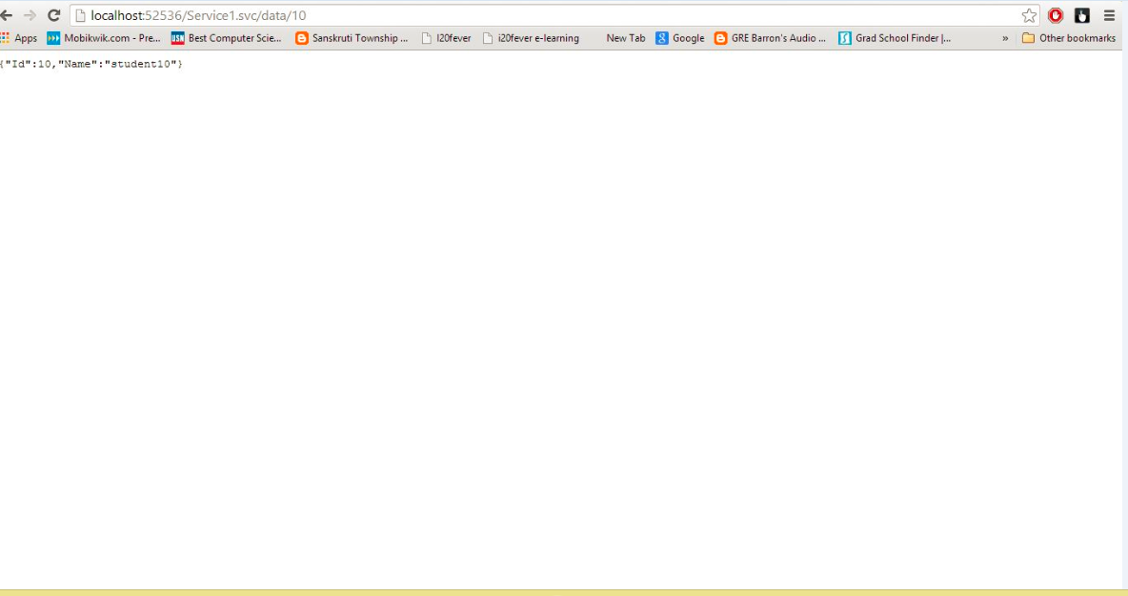

**Opera Mobile App View: Nokia N900 View**

